9.38: (a) 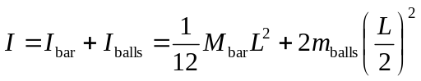
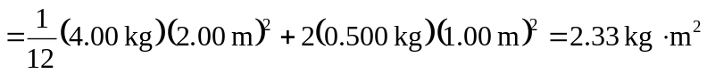

(b) 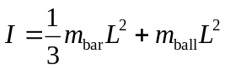

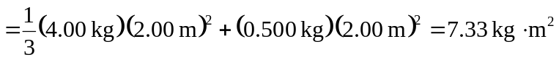

c) 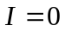 because all masses are on the axis

(d) 